**if (x >0)**

**z = 2*x;**

**else**

**z = -2*x;**

**if (( z == 0) && (y < 21))**

**System.out.println( “rubbish”);**

**else**

**System.out.println( “stupid”);**

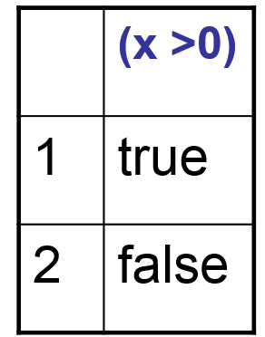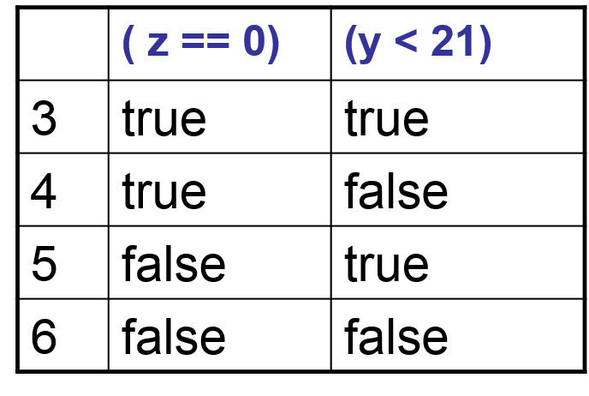

|  |  |  |
| --- | --- | --- |
| x | y | entries |
| 2 | 10 | 1,5 |
| 0 | 19 | 2,3 |
| 0 | 32 | 2,4 |
| -1 | 22 | 2,6 |